Lab Task 11.1

Exercise 1

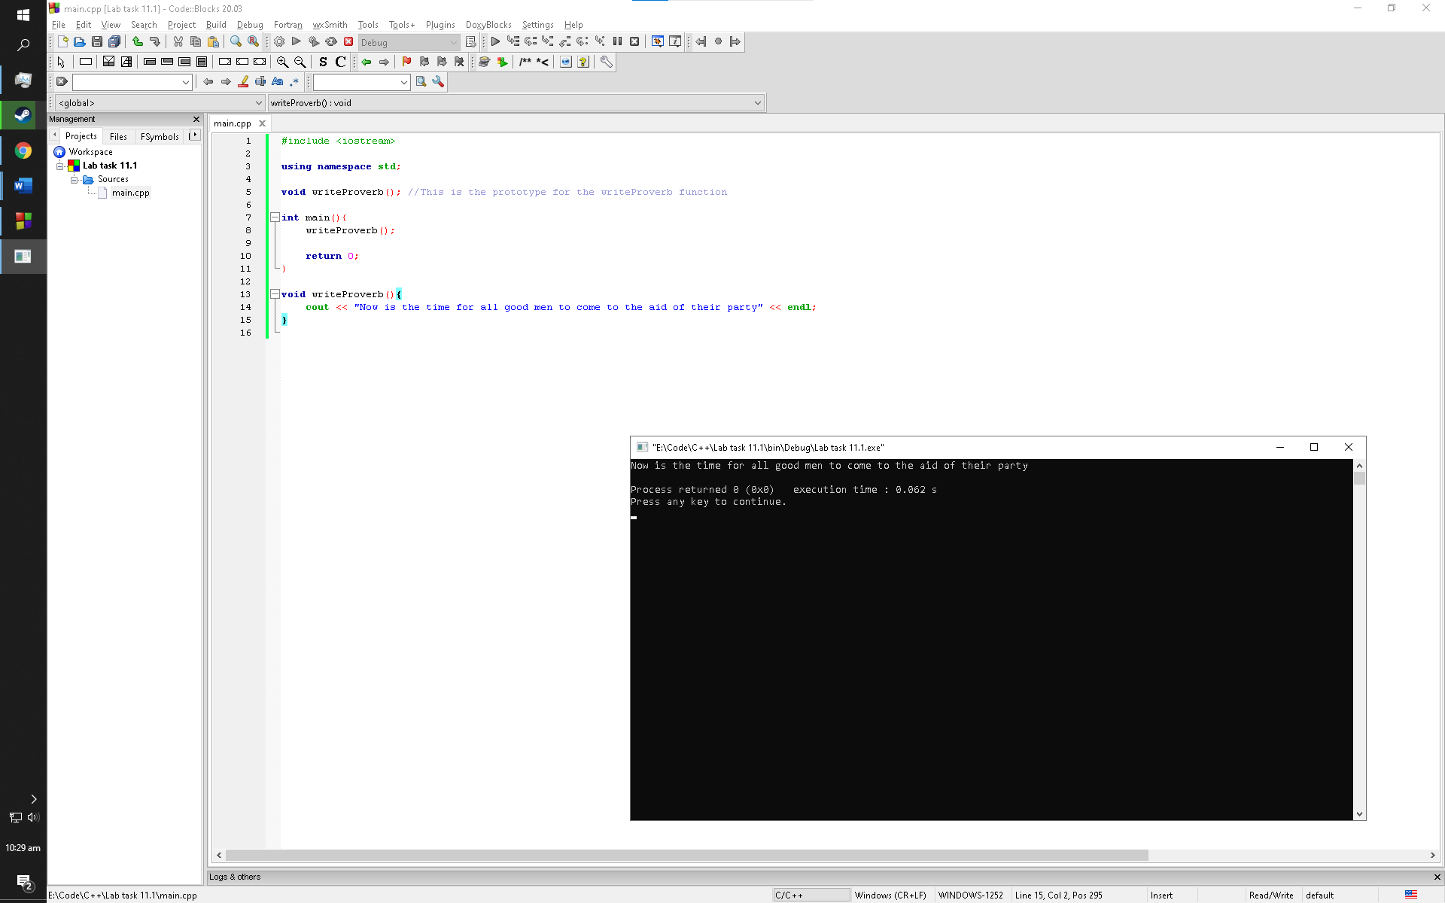

Observation: This program outputs the cout statement using a function

Lab Task 11.2

Exercise 1

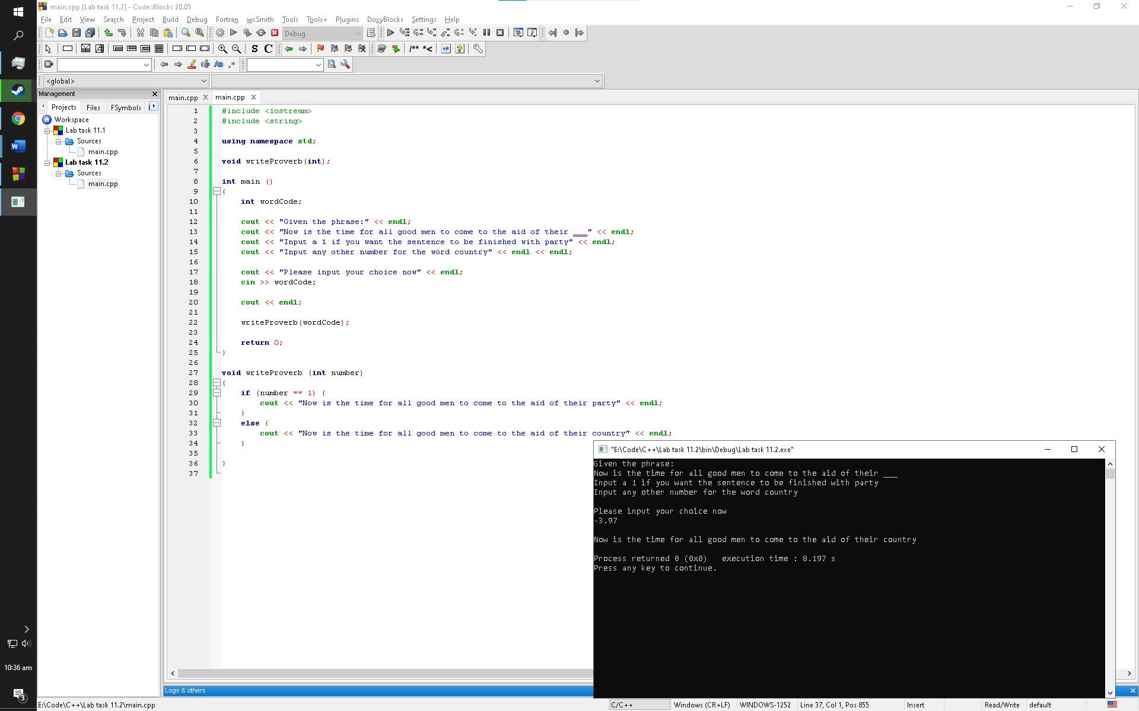

Observation: This program prompts the user to input 1 for the proverb to be printed with “party” or any other integer for the proverb to be printed with “country.” This is done by calling a function and checking the integer with if statements. If the user enters “-3.97,” the program omits .97 while storing it into the variable since the variable is initialized as integer. The program then outputs the cout statement in else manipulator since the condition for the if manipulator is not valid

Exercise 2

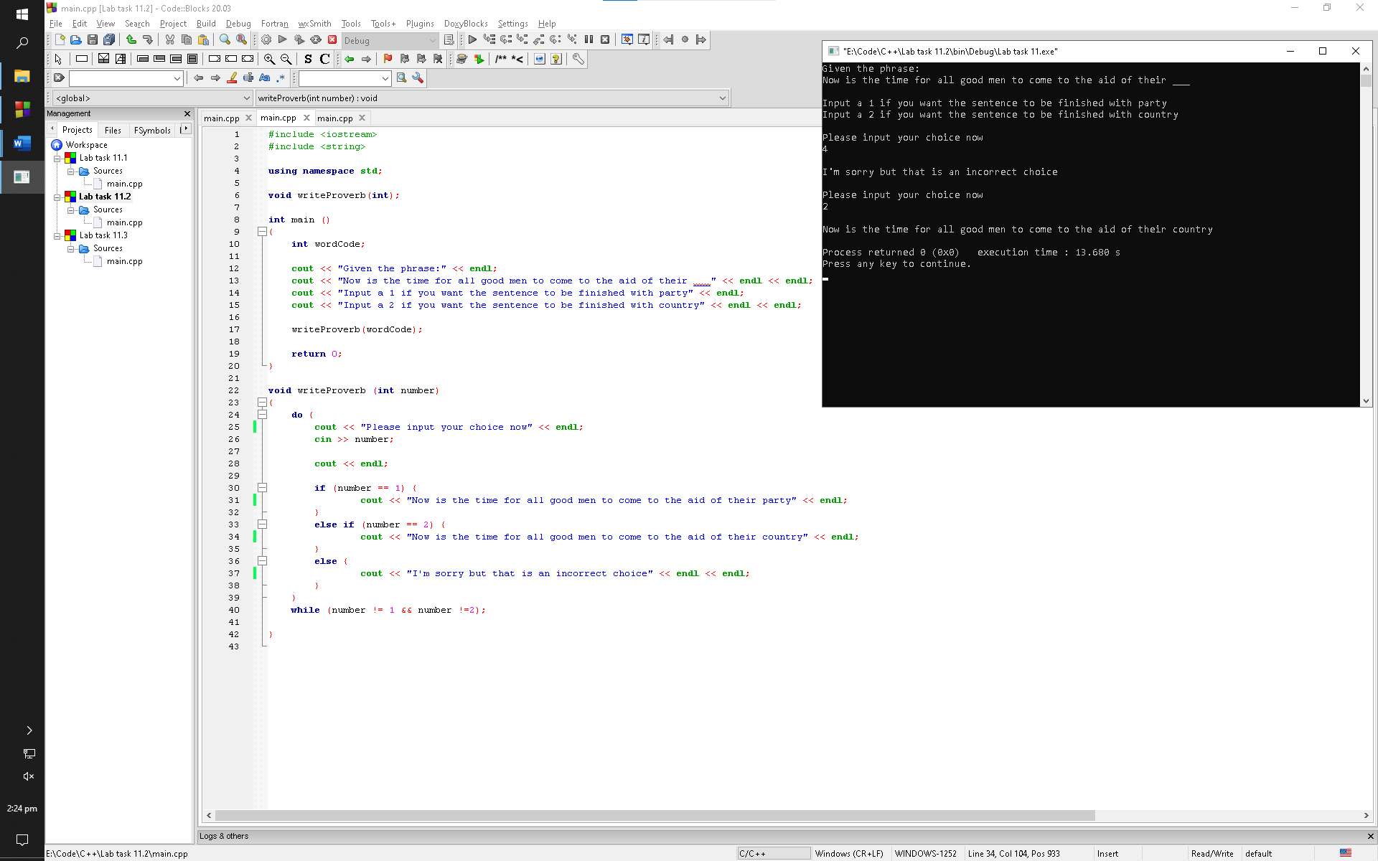

Observation: This program prompts the user with input requirements and then calls a function which loops around if the input requirements are not met. If met, the program outputs the cout statements corresponding the valid condition of if statement

Exercise 3

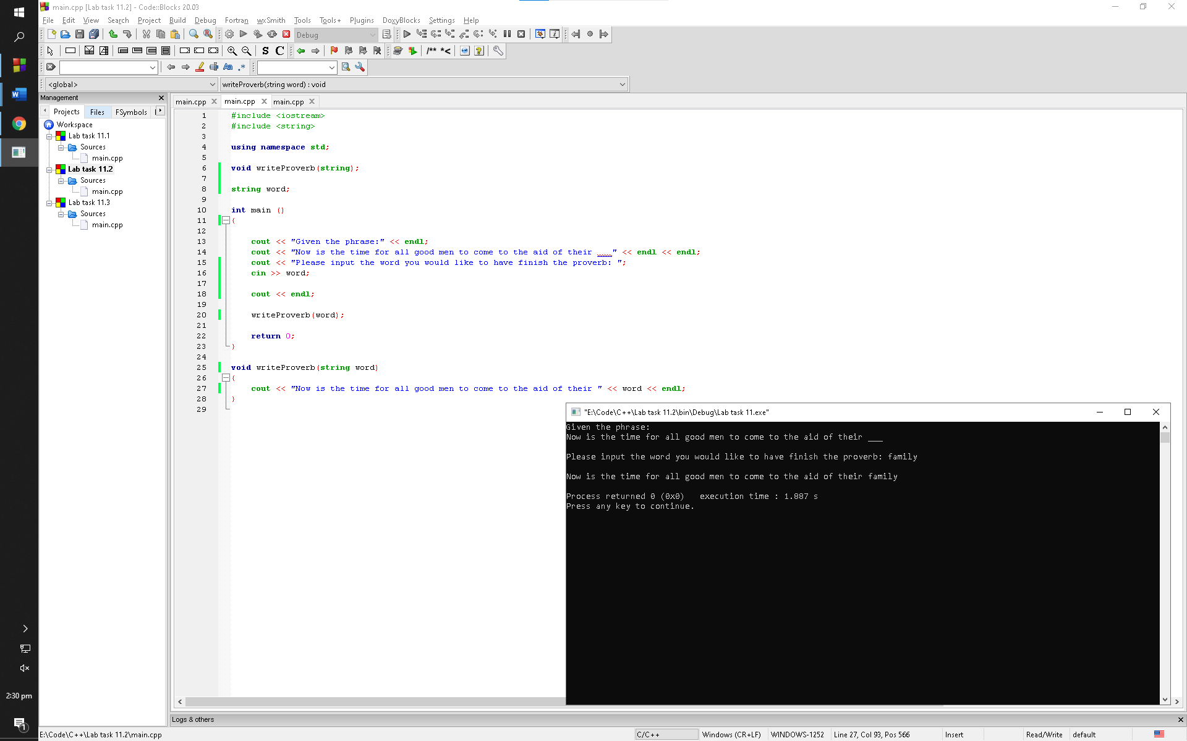

Observation: This program prompts the user to input any word they want to enter to complete the proverb. It then calls the function and prompts the user with the cout statement in it

Lab task 11.3

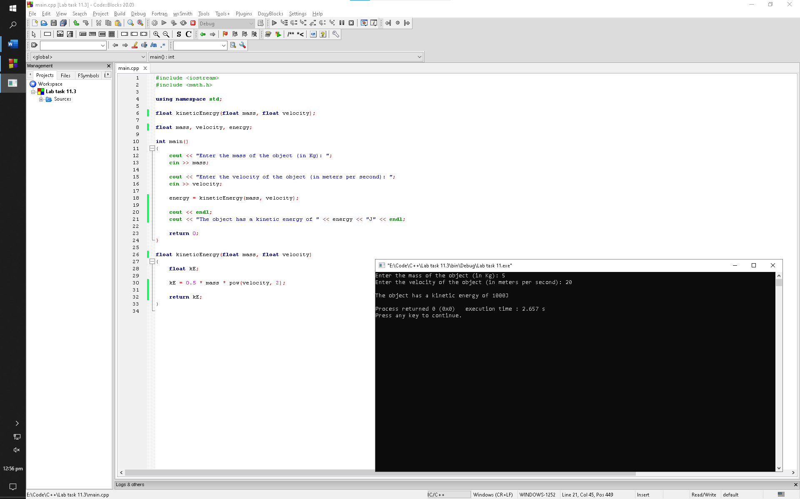

Observation: This program prompts the user to enter the velocity and mass for the its kinetic energy to be calculated. The program does it by passing the values to a function which calculates the kinetic energy and returns back the value for it to be printed along with a cout statement

Post lab

1

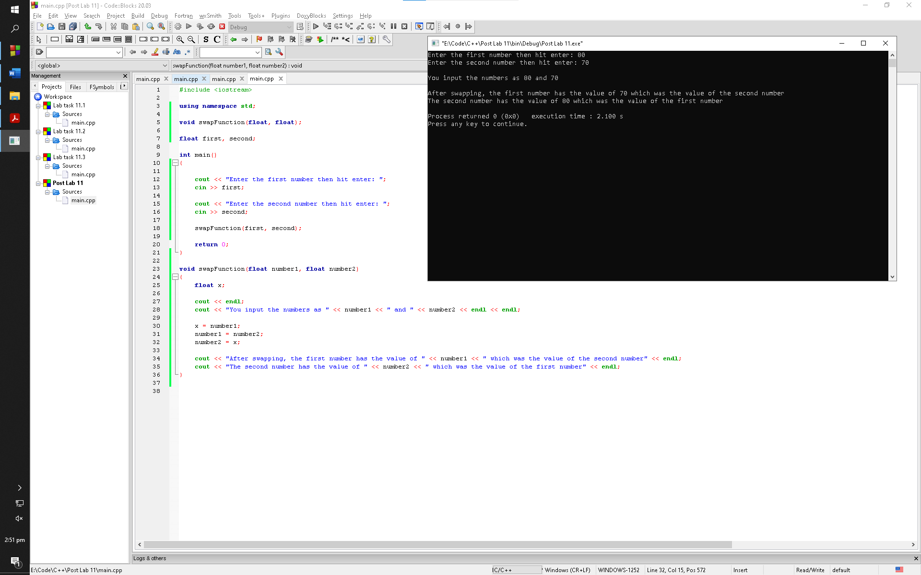

Observation: This program prompts the user to input two numbers to be swapped. It does this by passing both numbers into the function with different variables. The function within the program swaps the numbers and outputs them along with the cout statements

2

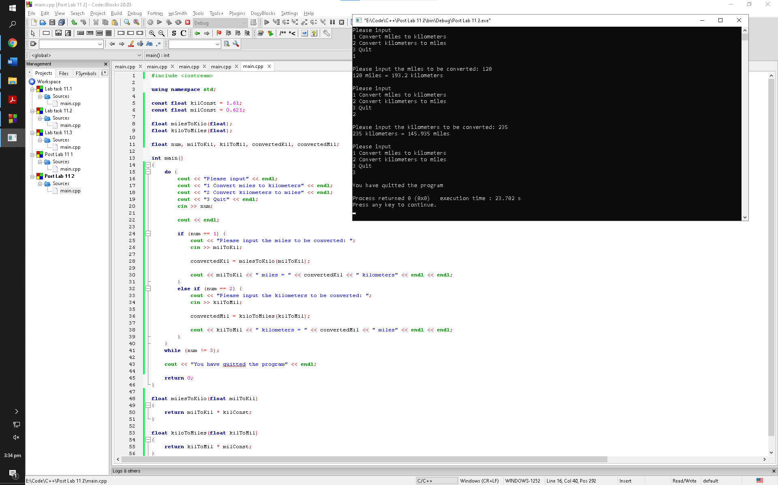

Observation: This program prompts the user with some input directions which are in loop in case the user inputs a value which is contradicting the input requirements. If the user wants to end the program, he/she has to type in “3.” If the user wants to convert distances, he/she has to input “1” or “2” depending on the input. In both cases, the program calls a function with respect of its use. The function converts the distance and return the value to the main function which then prints it along with a cout statement